V506 Practice Midterm Exam

1. Define the difference between a continuous and discrete variable and give an example of each.

2. Refer to the following distribution of ages:  
  
 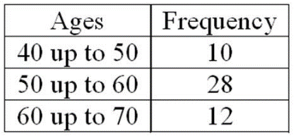   
  
For the distribution of ages just shown, what is the relative class frequency for the lowest class? 

3. A population consists of all the weights of all defensive tackles on a university's football team. They are Johnson, 204 pounds; Patrick, 215 pounds; Junior, 207 pounds; Kendron, 212 pounds; Nicko, 214 pounds; and Cochran, 208 pounds. What is the population standard deviation (in pounds)?

4. The distribution of a sample of the outside diameters of PVC pipes approximates a symmetrical, bell-shaped distribution. The arithmetic mean is 14.0 inches, and the standard deviation is 0.1 inches. About 68% of the outside diameters lie between what two amounts?

5. A board of directors consists of eight men and four women. A four-member search committee is randomly chosen to recommend a new company president. What is the probability that all four members of the search committee will be women? 

6. A gumball machine has just been filled with 50 black, 150 white, 100 red, and 100 yellow gumballs that have been thoroughly mixed. Sue and Jim each purchase one gumball. What is the likelihood that both Sue and Jim will get red gumballs? 

7. Judging from recent experience, 5% of the computer keyboards produced by an automatic, high-speed machine are defective. If six keyboards are randomly selected, what is the probability that none of the keyboards are defective?

8. Ball-Bearings, Inc. produces ball bearings automatically on a Kronar BBX machine. For one of the ball bearings, the mean diameter is set at 20.00 mm (millimeters). The standard deviation of the production over a long period of time was computed to be 0.150 mm. What percent of the ball bearings will have diameters of 20.27 mm or more?

9. A large manufacturing firm tests job applicants. Test scores are normally distributed with a mean of 500 and a standard deviation of 50. Management is considering placing a new hire in an upper-level management position if the person scores in the upper sixth percent of the distribution. What is the lowest score a new hire must earn to qualify for a responsible position?

10. The true sampling error is usually not known because ________.

|  |  |
| --- | --- |
| A. | µ is unknown |

|  |  |
| --- | --- |
| B. | µ is a random variable |

|  |  |
| --- | --- |
| C. | σ2 is unknown |

|  |  |
| --- | --- |
| D. | the sample mean cannot be computed |

11. The size of the sampling error is ________.

|  |  |
| --- | --- |
| A. | directly related to the sample size—in other words, the larger the sample size, the larger the sampling error |

|  |  |
| --- | --- |
| B. | directly related to the population mean—in other words, the larger the mean, the larger the sampling error |

|  |  |
| --- | --- |
| C. | inversely related to the sample size—in other words, the larger the sample size, the smaller the sampling error |

|  |  |
| --- | --- |
| D. | inversely related to the population standard deviation—in other words, the smaller the standard deviation, the larger the sampling error |

12. The weight of trucks traveling on a particular section of I-475 has a population mean of 15.8 tons and a population standard deviation of 4.2 tons. What is the probability a state highway inspector could select a sample of 49 trucks and find the sample mean to be 14.3 tons or less? 

|  |
| --- |
| 13. A research firm needs to estimate within 3% the proportion of junior executives leaving large manufacturing companies within three years. A 0.95 degree of confidence is to be used. Several years ago, a study revealed that 21% of junior executives left their company within three years. To update this study, how many junior executives should be surveyed? |

14. A random sample of 85 supervisors revealed that they worked an average of 6.5 years before being promoted. The population standard deviation was 1.7 years. Using the 0.95 degree of confidence, what is the confidence interval for the population mean? 

15. Consider a two-tailed test with a level of confidence of 80.30%. The z-value is ________.

16. The mean weight of newborn infants at a community hospital is 6.6 pounds. A sample of seven infants is randomly selected and their weights at birth are recorded as 9.0, 7.3, 6.0, 8.8, 6.8, 8.4, and 6.6 pounds. Does the sample data show a significant increase in the average birthrate at a 5% level of significance? 

17. It is claimed that in a bushel of peaches, less than 10% are defective. A sample of 400 peaches is examined and 50 are found to be defective. What is the *p-*value?

18. A null hypothesis makes a claim about a __________.

|  |  |
| --- | --- |
| A. | Population parameter |

|  |  |
| --- | --- |
| B. | Sample statistic |

|  |  |
| --- | --- |
| C. | Sample mean |

|  |  |
| --- | --- |
| D. | Type II error |

19. A recent study focused on the amount of money single men and women save monthly. The information is summarized next.   
  
 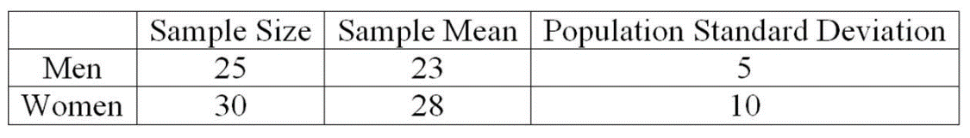   
  
At the .01 significance level, what is the conclusion about the way women and men save? 

20. An investigation of the effectiveness of a training program to improve customer relationships included a pre-training and post-training customer survey. To compare the differences they computed (post-training survey score - pre-training survey score). Seven customers were randomly selected and completed both surveys. The results follow.  
  
 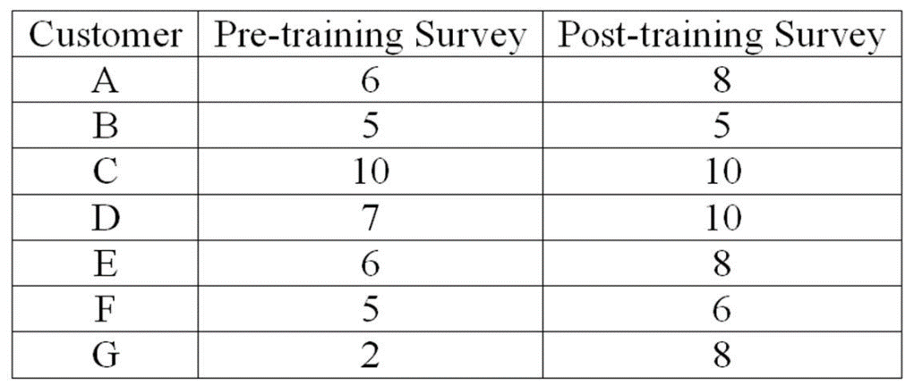   
  
What is the value of the test statistic? 